**PID LINE FOLLOWER**

**Semester: V**

**Team members:**

1.M SATWIK RAI 2. KANZAL HAQ A

3.DISHA RAVI

**Block/Circuit Diagram:**

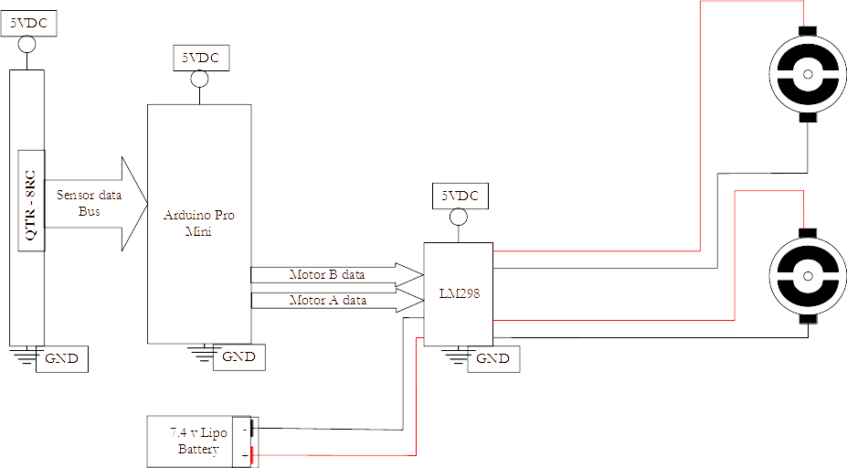

**Abstract:**

A Line Follower Robot is an autonomous robot which can follow either a black or white line that is drawn on the surface consisting of a contrasting color. It is designed to move automatically and follow the made plot line. PID control of line follower is a method consisting of Proportional, Integral & Derivative functions to improve the movement of the robot. The robot uses several sensors to identify the line thus assisting the bot to stay on the track. The robot is driven by DC Motors to control the movement of the wheels. Arduino pro mini is used to perform and implement PID algorithms to control the speed of the motors steering the robot to travel along the line smoothly. This project aims to implement the PID algorithm and control the movement of the robot by proper tuning of the control parameters and thus achieve better performance.